CAMPUS AWARD for more sustainability: And the winners are...
Each year the KELLNER & STOLL-STIFTUNG and its partners honour young scientists with the "CAMPUS AWARD: Research for a sustainable future". Due to the ongoing corona crisis, the award ceremony scheduled for May has been cancelled, but the jury has made its decision nonetheless on who will win the prize for 2019/2020. This year, the award goes to engineer Dr. Georg Pesch and marine biologist Julian Engel from the Leibniz Centre for Tropical Marine Research (ZMT). Both are graduates of the University of Bremen.
“We owe it to all the remarkable nominations to honour them and choose a winner,” explains Dr. Rita Kellner-Stoll from the KELLNER & STOLL-FOUNDATION. “Of course we also hope to be able to celebrate the award winners in person again next year.” Georg Pesch from the Department of Production Engineering at the University of Bremen receives prize money of 2,000 euros for his doctoral thesis, which he completed with top marks. Julian Engel receives 1,000 euros for his Master’s thesis, which he completed in the joint programme "International Studies of Aquatic Tropical Ecosystems (ISATEC)" of the Leibniz Centre for Marine Tropical Research (ZMT) and the University of Bremen.
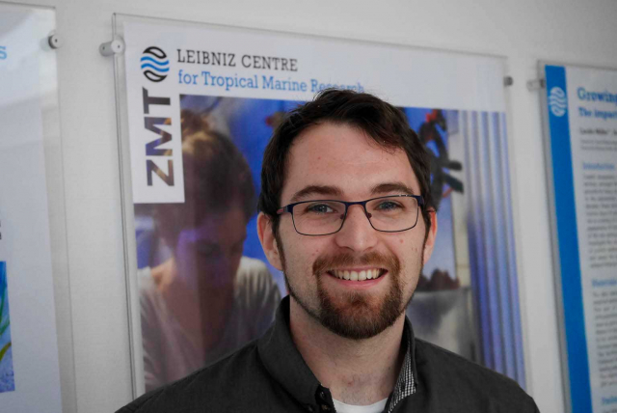
„We need interdisciplinary approaches to achieve sustainability goals,” says marine biologist Julian Engel from ZMT. | Photo: KELLNER & STOLL-FOUNDATION FOR CLIMATE AND ENVIRONMENT
Winner initiates marine conservation area in the Philippines
At the beginning of Julian Engel's thesis was a fish: The pelagic thresher shark lives in depths that man rarely enter. Near the island of Malapascua in the Philippines, however, divers can observe the thresher shark at so-called "cleaning stations", where small marine animals cleanse the shark from parasites. As a top hunter, the thresher shark plays an important role in the local ecosystem, but the animals are increasingly threatened. Destructive fishing practices and overfishing are reducing the populations of thresher sharks and other fish species. Tourism is already exceeding capacity. “There should therefore be alternative sources of income for local people, combined with a development towards eco-tourism that takes into account the various interests from fishermen to diving operators,” says Julian Engel.
In his Master's thesis at ZMT, the 30-year-old investigated the question of how to foster such a symbiosis on the island of Malapascua. During his interviews he always focused on having a dialogue with all parties involved. After completing his research, Engel returned to the island to present his findings to fishermen, island administrators and other stakeholders.
His mission fell on fertile ground: Not least at Julian Engel's suggestion, the various stakeholders discussed the establishment of a marine protected area (MPA) around Chocolate Island in the southwest of Malapascua – a project that the organisation "People and the Sea" continued to pursue. Parts of Julian Engel’s prize money are now going to Malapascua to support the local people whose tourist activities are affected by the Corona crisis.
“We must learn to listen to each other more”
Jury member Fabio Nicoletti from the Board of the University of Bremen Alumni Association praised the Master's thesis for its “balanced consideration of all dimensions of sustainability”. The jury was also impressed by Engel’s critical reflection of the research results and his considerations of alternatives and their consequences. “With great personal commitment, Julian Engel organised and implemented the exchange of knowledge with the local population, officials and non-governmental organisations in a careful, culturally sensitive manner,” said Nicoletti.
“What I associate with the award and my work above all is that we need interdisciplinary approaches to achieve sustainability goals,” says Julian Engel. “We must learn to listen to each other more and approach each other with understanding and affection in order to learn from each other.” Engel now works for the marine conservation organisation OceanMind in England campaigning for sustainable fishing.
Better recycling for precious metals
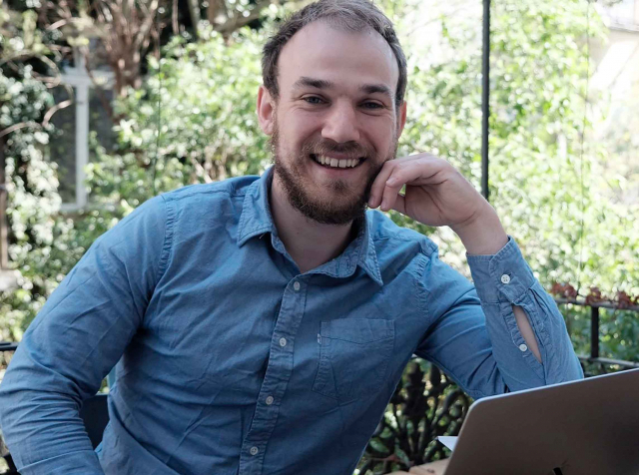
Prize-winner Georg Pesch convinced that process engineers have great skills to make the world more sustainable. | Photo: Private
The prize winner Dr. Georg Pesch dealt with a topic from process engineering in his dissertation. The sorting and selection of very small particles according to shape, material or size from large quantities of material has so far been an unsolved task with grave consequences for the environment and negative effects on the complete recovery of precious metals from electronic waste. The same applies to the recovery of gold from valuable sludge or dust. Ecological concerns are raised in view of the scarcity of resources and the effort that is often required to extract the precious metals using toxic additives such as mercury.
A novel process is the so-called dielectrophoretic filtration. It allows micro-particles to be sorted and is based on the effect of an electric field in which the particles are polarised. Prize-winner Georg Pesch describes this process in his doctoral thesis and demonstrates its effectiveness. The results of his work make it possible to design a completely new separation apparatus that can perform a large number of previously unsolved, environmentally relevant separation tasks.
Several companies have already shown interest in testing this technology in practice. Work is currently underway on a larger demonstration plant to limit the risks for a market launch. If everything goes well, an important contribution can be made to resource protection and improved resource utilisation.
"Award has signalling effect"
For Georg Pesch the award came as a surprise. “Ever since my Bachelor's degree, I have been convinced that process engineers have great skills to make the world more sustainable. But this should be taught even more consistently. The award for my dissertation therefore also has a great signalling effect."
Reiner Stoll, jury member for the KELLNER & STOLL-FOUNDATION, says: "What was very convincing for us was the triad of clear analysis of the environmental pollution caused by the extraction and recycling of valuable metals, the development or refinement of the method (dielectrophoresis) for the problem and the description of the way to solve existing separation problems on an industrial scale".
About the CAMPUS AWARD
The CAMPUS AWARD honours outstanding theses written on the campus of the University of Bremen that are dedicated to the sustainable use of resources, the protection of the environment, the climate and the oceans. The award was established in 2016 and is presented once a year by the KELLNER & STOLL-FOUNDATION FOR CLIMATE AND ENVIRONMENT, the Leibniz Centre for Tropical Marine Research (ZMT), the University of Bremen and the University of Bremen Alumni Association. It is endowed with a total of 3,000 euros. The Bremen companies ADLER Solar, REETEC and ecolo - Agency for Ecology and Communication support the CAMPUS PRIZE as sponsors.
More Information: www.campuspreis.de

- Andrea Daschner
+49 421 23800 - 72
andrea.daschner@leibniz-zmt.de
Details
- Dr. Rita Kellner-Stoll | Vorsitzende des Stiftungskuratoriums KELLNER & STOLL-STIFTUNG FÜR KLIMA UND UMWELT
Details
- Meike Mossig | Hochschulkommunikation und Marketing Universität Bremen
Details

